**Creative Writing**

You are advised to spend about 45 minutes on this section.

Write in full sentences.

You are reminded of the need to plan your answer.

You should leave enough time to check your work at the end.

**Describe image 1**

**Write a description inspired by this image.**

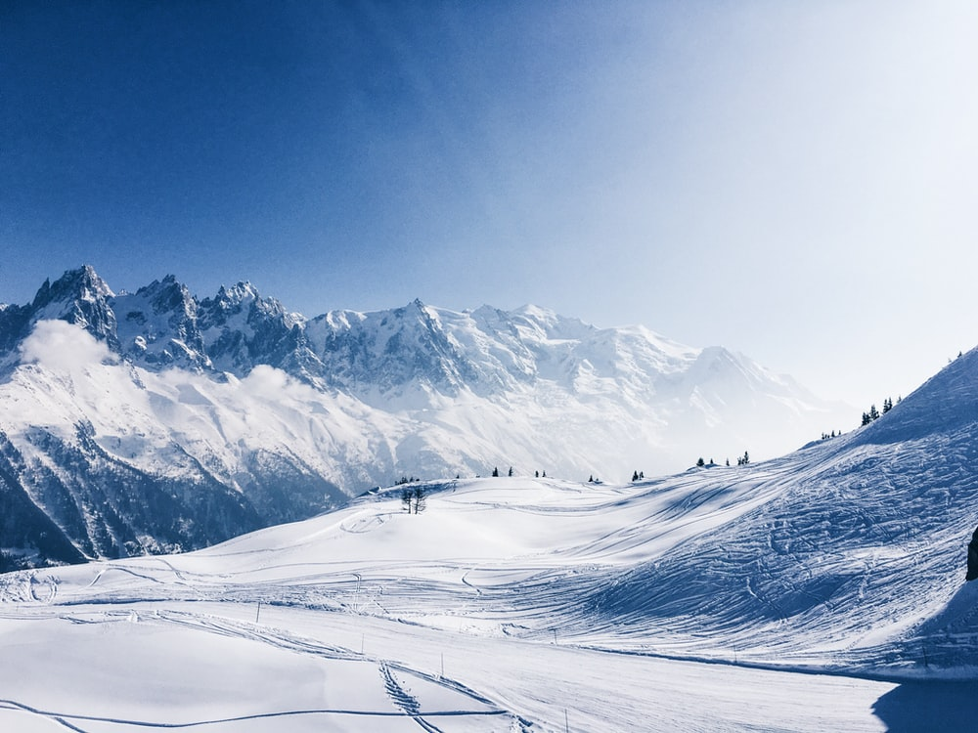

**Success Criteria:**

* Aim to write at least 4 paragraphs.
* Try to consider the mood and atmosphere of your setting.
* Use a variety of descriptive techniques, including appealing to the senses.
* Try to include a simile, a metaphor and personification.
* Use powerful verbs and adjectives.
* Use all sentence types (complex, compound and simple sentences).
* Use a variety of punctuation (including semi-colon).

**AO5- 24 marks**

**AO6- 16 marks**