Work, energy, and machines
Task 1
Work, energy, and machines
Work is done when a force moves an object and energy is transferred from one store to another.
1 The table has some examples of work being done.
In each case, state the force and the distance.
The first one has been done for you.

Action | Force | Distance
box pushed along the floor | friction | distance the box is moved
weightlifter lifting a weight
catapult pulled back
car crashes, leaving a dent

2 State two examples of simple machines in everyday use.
………………………………………………………………………………………………………………………………………………
………………………………………………………………………………………………………………………………………………

3 Machines make work easier. Draw diagrams to illustrate and explain the following statements.
a A screwdriver makes it easier to take the lid off a paint can.

……………………………………………………………………………
……………………………………………………………………………
……………………………………………………………………………
……………………………………………………………………………
……………………………………………………………………………

b A spanner with a longer handle is easier to use than one with a shorter handle.

……………………………………………………………………………
……………………………………………………………………………
……………………………………………………………………………
……………………………………………………………………………
……………………………………………………………………………

c A pulley system is used to lift a lifeboat.

……………………………………………………………………………
……………………………………………………………………………
……………………………………………………………………………
……………………………………………………………………………
……………………………………………………………………………

Task 2
Thermal energy
An object’s thermal energy depends on its mass, temperature, and what it is made of.
Read these statements and decide whether they are true or false.
Thermal energy is the same as temperature. T / F
Some materials heat up more quickly than others. T / F
A full kettle of water takes longer that a half-filled kettle to boil. T / F
Ice cubes cool drinks by transferring cold energy to the warmer drink. T / F

Task 3
Investigating cooling
Etta investigates whether the starting temperature of a liquid affects the rate of cooling. The temperature change will be recorded for 200 cm³ of water over a 5-minute period for different starting temperatures. These are her results.

Starting temp. (°C) | Final temp. (°C) | Temp. fall (°C)
80 | 70
75 | 66
70 | 62
65 | 59
60 | 55

1 Identify the:
independent variable …………………………………………………………………………………………
dependent variable …………………………………………………………………………………………
control variables. …………………………………………………………………………………………
2 Calculate the temperature fall values, and complete the table above.
3 Plot a graph of temperature fall against starting temperature.


4 Do the results show a link between starting temperature and temperature fall? If so, describe the relationship.
……………………………………………………………………………………………………………………………………………
……………………………………………………………………………………………………………………………………………
5 Room temperature was 20 °C.
What temperature will all of the water be after an hour? Explain your answer.
……………………………………………………………………………………………………………………………………………
……………………………………………………………………………………………………………………………………………
……………………………………………………………………………………………………………………………………………

Task 4
Thermal energy transfer by particles
1 Draw the arrangement of particles in a solid, liquid, and gas.

Solid | Liquid | Gas

2 For each row, tick all boxes where you think the description is of particles in a solid, liquid, or gas.

Description of particles | Solid | Liquid | Gas
close together
arranged in a pattern
can move around each other

3 Draw a diagram to show heat passing through a metal rod. Describe, using these key words, how the thermal energy is transferred.

vibrate | faster | particles | electrons | conduction | collide | thermal energy

……………………………………………………………………………
……………………………………………………………………………
……………………………………………………………………………
……………………………………………………………………………
……………………………………………………………………………

4 The heating element in a kettle is always at the bottom.
Add to the diagram of a kettle to show how all the water in the kettle heats up, rather than just the bottom layer.
Use these key words.

sink | dense | particles | rise | faster | convection current

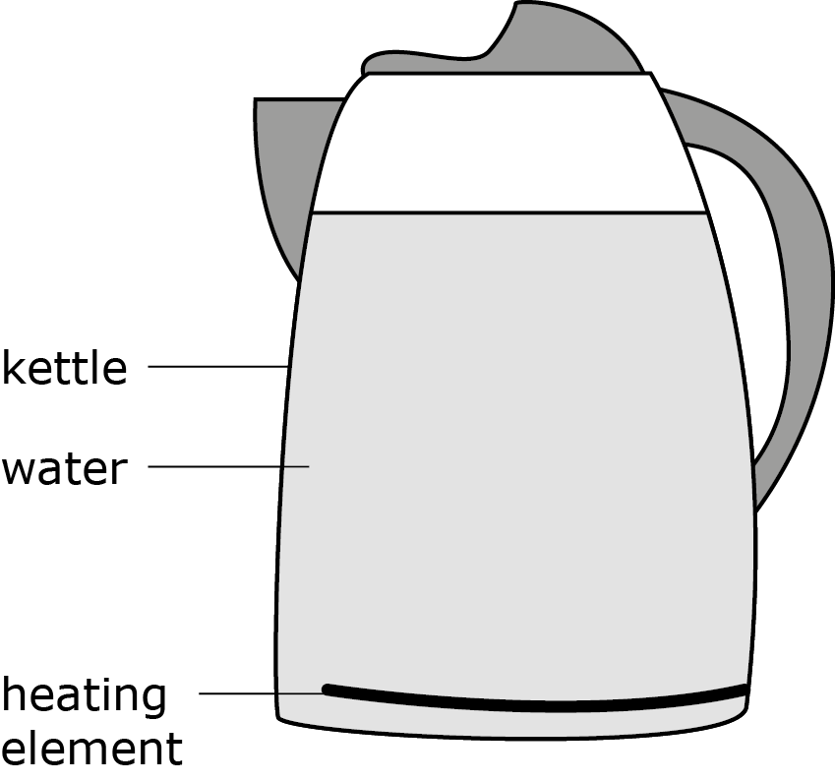
……………………………………………………………………………
……………………………………………………………………………
……………………………………………………………………………
……………………………………………………………………………
……………………………………………………………………………

Task 5
Thermal energy transfer by radiation
If you are standing in front of a bonfire on a cold night and someone walks between you and the fire, you can no longer see the fire and instantly feel cold. Draw a diagram, and explain these observations using the following key words.

shadow | straight line | radiation | thermal | wave

……………………………………………………………………………
……………………………………………………………………………
……………………………………………………………………………
……………………………………………………………………………
……………………………………………………………………………

Task 6
Insulation
Each of these questions has a set of key words to use in your answer.
1 Explain why a bird fluffs out its feathers in winter to keep warm.

trap | insulator | particles | far apart | conductor | convection | transfer
………………………………………………………………………………………………………………………………………………
………………………………………………………………………………………………………………………………………………
………………………………………………………………………………………………………………………………………………

2 Explain why marathon runners are given a shiny metallic sheet to wear at the end of the race.

radiates | reflects | cool | hot
………………………………………………………………………………………………………………………………………………
………………………………………………………………………………………………………………………………………………
………………………………………………………………………………………………………………………………………………

3 Explain why flasks used to keep liquids hot or cold have a vacuum layer.

vacuum | conduction | convection | radiation | particles | wave
………………………………………………………………………………………………………………………………………………
………………………………………………………………………………………………………………………………………………
………………………………………………………………………………………………………………………………………………

