More about levers
Task
The diagram shows two classes of lever. The load is the output force, and the effort is the input force. In the first type of lever, the pivot (P) is always between the load (L) and the effort (E). In the second, the load is always between the pivot and the effort.

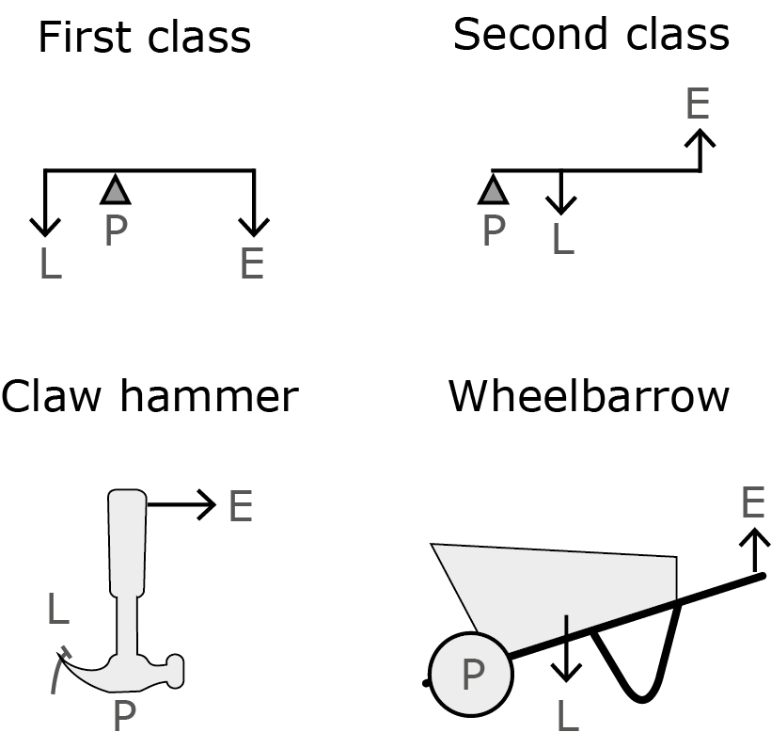

1 Sort the list of simple machines into first class levers and second class levers. You could look in books or on the internet to find images of each machine to help you to answer.
bottle opener; paper cutter; spade; see-saw; spanner; door; hole punch; scissors

First class levers | Second class levers

2 Choose one example from the table above for each type of lever, and explain how the tool makes work easier. How could it be improved?
In your answer, you should explain how to calculate the work done by the effort (the person) and the work done by the load:

work done = force × distance moved

……………………………………………………………………………………………………………………………………………
……………………………………………………………………………………………………………………………………………
……………………………………………………………………………………………………………………………………………
……………………………………………………………………………………………………………………………………………
……………………………………………………………………………………………………………………………………………
……………………………………………………………………………………………………………………………………………
……………………………………………………………………………………………………………………………………………
……………………………………………………………………………………………………………………………………………
……………………………………………………………………………………………………………………………………………
……………………………………………………………………………………………………………………………………………
……………………………………………………………………………………………………………………………………………
……………………………………………………………………………………………………………………………………………

